**Final Project**

1. Gameplay description

* core mechanic: **Relationship simulation role-playing games**

Play as transfer student, with an end goal of confessing to the one other student.

1. Input

Using Twine to make choices.

1. Visual style

Background: (Asian)Japanese or Taiwanese classroom

modern style

1. Audio style

Parlour music

1. Interface sketches

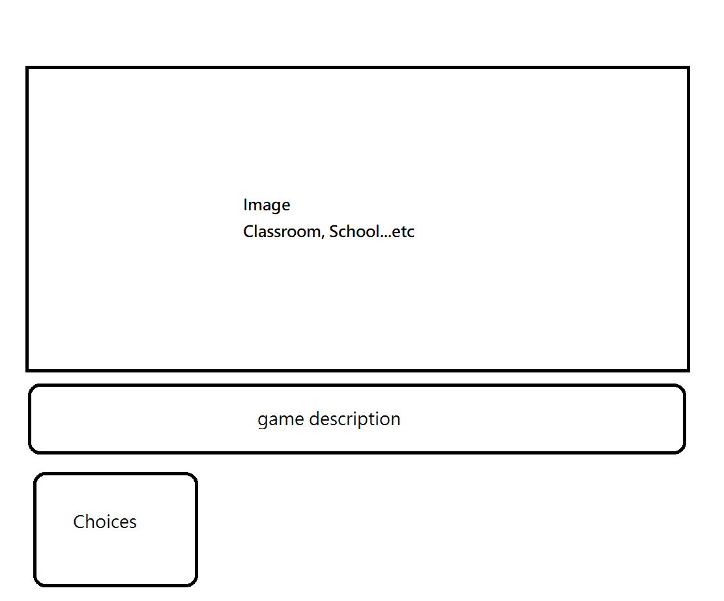

1. Story/theme description
   * You are a male transfer student, but you transfer to the Girls' School by accident
   * You become the only boy in the school.
   * You have to find the love in the school.
2. the “low-bar “of you will create (this should still be a “complete game”)
   * Win/Lose status
   * At least 4 different routes
   * Without images/music
3. a target that you expect to get done
   * using Twine to create random variable- Make event result randomly
   * Control each girl’s relationship level
   * Different ending
4. a desired high-bar if things go exceptionally well.
   * With images/music
   * Combine the psychological test
   * Some fights event- attack system, hp…etc